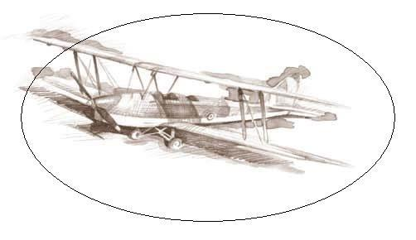
VILLAGE OF AIRPORT DRIVE
Business Licensing Period
January 1 to December 31
Sales Tax Rate 7.60%
Website
airportdrivemo.com
Contact Information
Village of Airport Drive
25150 Demott Drive
Joplin, MO 64801
Phone: (417) 623-6744
Fax: (417) 623-7839
Village Clerk
Sue Hirshey
Email: Sue@airportdrivemo.com
Additional Contacts
Missouri Depart. of Revenue Missouri Sales Tax & Certificate of No Tax Due
(573) 751-9268
Email: taxclearance@dor.mo.gov

Airport Drive’s Sales Tax
Jurisdiction Code –
00424-097-000

Missouri Alcohol & Tobacco Control – Missouri Liquor License
(573) 751-2333
Carl Junction Fire Protection Dist. – for fire/safety inspections
(417) 649-6062
Jasper County Health Depart.
(417) 358-3111
Jasper County Collector’s Office – for Merchant’s License
302 S. Main, Carthage MO
417-625-4324

25150 DEMOTT DRIVE
JOPLIN, MISSOURI 64801
Business License Information
Chapter 605 of the Airport Drive Municipal Code regulates licenses for businesses, followed by the additional requirements by the type of business being opened. This information must be submitted, and your license application approved prior to opening.
All New Businesses:
- Complete the Business License Application.
- Verify the Zoning Designation of the property.
- Contact the Carl Junction Fire Protection District for inspection of the building.
- Remit the license fee by cash, check, or credit card. Checks should be made payable to Village of Airport Drive.

Additional Requirements by Business Type
Retail
- Missouri Sales Tax number and certificate of No Tax Due with Airport Drive designation

Food Preparation/Sales
- Missouri Sales Tax number and certificate of No Tax Due with Airport Drive designation
- Certification of existence & maintenance of grease, oil, or sand interceptor by a licensed plumber
- Food Trucks must have written permission from the land owner for use their property

Alcohol Sales/Service
- Prior to opening new business, approval of Alcoholic Beverage License by the Board of Trustees.
- If a renewal, a completed Liquor License Renewal Sheet
- Copy of State of Missouri Liquor Licenses

Home Based Businesses
- Same requirements for all businesses of same type.

Contractor or Sub-Contraction Licenses
- Complete Contractor’s License application
- Proof of General Liability and Workman’s Compensation Insurances, with Airport Drive listed as Certificate Holder

